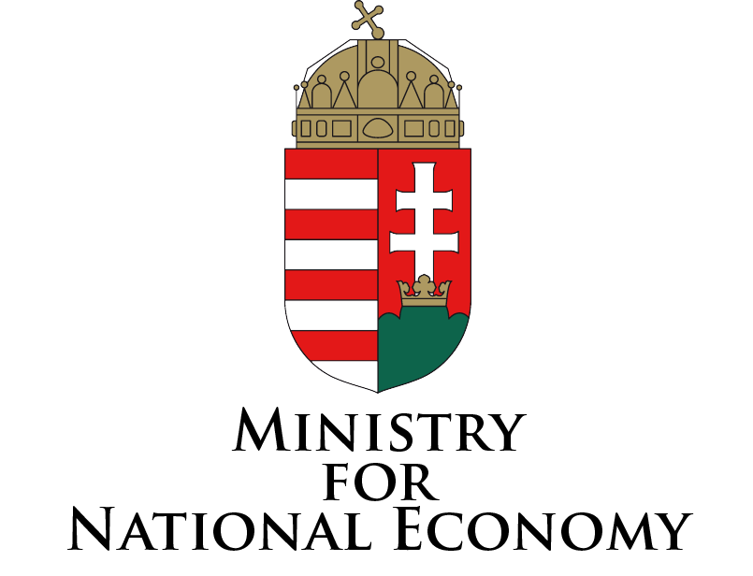

Central Administration of
National Pension Insurance

Pensions Adequacy and Sustainability

Conference of

the Central Administration of National
Pension Insurance in Hungary

organised
in cooperation with

the Ministry for National Economy

20 September 2013

Pension Insurance Center
Fiumei út 19/A 1081 Budapest

Programme of the conference

Friday, 20 September 2013

8.30 – 9.00 Registration

9.00 – 9.15 Welcome and opening remarks

Prof. Dr. József Mészáros
General Director, Central Administration of National Pension Insurance

Péter Benő Banai
Deputy State Secretary, Ministry for National Economy

9.15 – 12.50 Implicit depts in social security systems
Moderator: Chris Daykin
GCAE Social Security Subcommittee
UK

09.15 – 09.45 Prof. Dr. Robert Holzmann
World Bank

09.45 – 10.15 Prof Dr. Bernd Raffelhüschen
Institut für Finanzwissenschaft
Albert-Ludwigs-Universität Freiburg

10.15 – 10.45 open discussion

10.45 – 11.00 Coffee Break

11.00 – 11.20 József Banyár
Hungarian Financial Supervisory Authority - Senior Advisor

11.20 – 11.40 András Bodor
World Bank - Senior Economist

11.40 – 12.00 Csaba Fehér
IMF – Senior Economist

12.00 – 12.20 Ágnes Tardos
National Bank of Hungary - Director and Head of Statistics

12.20 – 12.40 open discussion

12.40 – 14.00 Lunch

14.00 – 17.15 pensions adequacy and sustainability

Moderator: Edward Palmer
Swedish Social Insurance Agency &
Uppsala University

14.00 – 14.30 Monika Queisser- tbc - OECD - Head of Social Policy

14.30– 15.00
Fritz von Nordheim Nielsen
European Commission – Deputy Head of Unit
Social Protection & Activation Systems

15.00 – 15.30 open discussion

15.30 – 15.50 Coffee break

15.50 – 16.15 “Sustainability of pension systems in Europe”
Chris Daykin - GCAE Social Security Subcommittee
UK

16.15 – 16.40 "Measurements of adequacy and sustainability. Mechanisms of redistribution and financing against poverty"
Marianna Papamichael - National Actuarial Authority
Greece

16.40 – 17.05 "Assessing the sustainability of pension reforms in Europe: a pension wealth approach".
Dr. Aaron G. Grech – Bank of Malta & London School of Economics and Political Science

17.05 – 17.30 open discussion

17.30 – 17.45 Closing remarks
Prof. Dr. József Mészáros
General Director, Central Administration of National Pension Insurance

