Gabor Hanak, Chairman of Groupe Consultatif
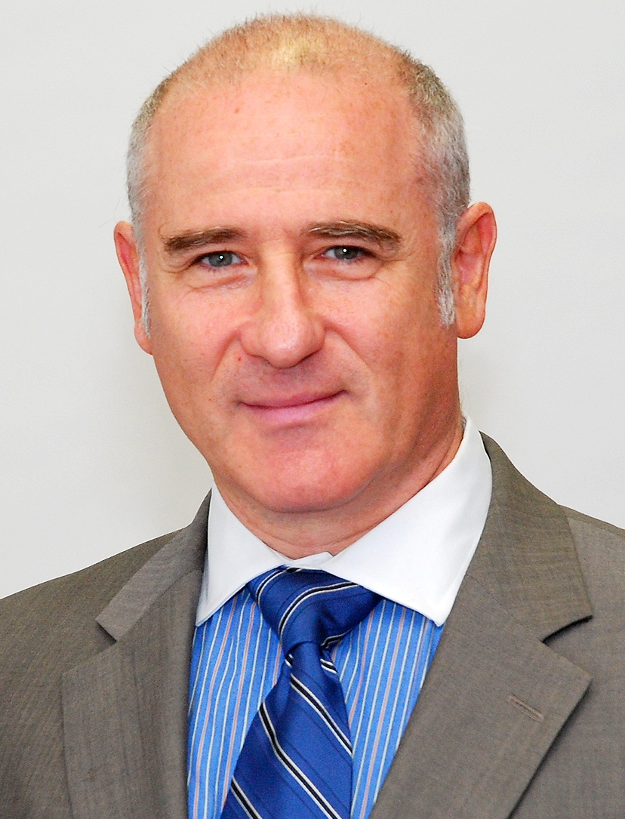
Question 1:

Personal background

I became an actuary in a non-traditional way as the profession in my country, Hungary, was suspended for decades, similarly to the countries of the former Soviet bloc. The IAA and the UK Profession helped to revive actuarial life in the early 1990’s in this region’s countries. In my late 30’s I turned from mathematician to actuary in the course of five years. I attended the first Groupe meetings in 2000 in Bilbao and have gradually become familiar with the European issues which the Groupe pursues and have been active in the discussions at meetings and in between meetings. I became the Chairman of the Groupe in October 2011

Question 2:

What kind of aim does the Groupe have, what are the objectives and what role does it play?

The overall goal of the Groupe should be to become an indispensible, independent and impartial, professional, acknowledged and respected leading advisor to European institutions in matters of actuarial relevance in pursuit of public interest. By this the Groupe will contribute to be better placed individual actuaries who provide high quality services in various areas, from industry through regulators and supervisors to consumer bodies. The Groupe should aim to help Member Associations in assessing and meeting the high demand for young actuaries, upholding quality at the same time.

Question 3:

What are the future challenges for the Groupe?

The Groupe should maintain its independence and impartiality and provide high quality professional technical advice in an over-politicized arena of insurance and pensions. We will have to respond to the various phases of the accelerating consultation processes and at the same time build more intensive ties to a wider range of stakeholders involved in insurance and pension than in the past. This will be a demanding job as the Groupe’s professional activity is based on volunteer contribution from actuaries all around in Europe.

